**A Project Paper on Hostel Gym Management System**

Submitted By

J.Sravan

ID : 17A91A1218

Ch.Vikas Reddy

ID : 17MH1A0512

M.D.A.Sampada

ID : 17A91A1234

P. Sai Rishmitha

ID : 17A91A1242

**Abstract**

This Project "Hostel Gym" is an easier and more convenient way to monitor the Students .

The Admin, is able to view all the details .This project is a computer-based program and it reduces the paper work. This system maintains the trainers and students details , to provide customized reports about their presence in the Gym .

**Introduction**

The main purpose of this project is to make the data of trainers and students easily accessible and also making it easy to keep details in a secured database.

**Project Objectives**

* Reducing time taken to enter trainer and student data.
* Making the trainer data easily accessible.
* To register the students easily.
* To make customized reports.
* To mark the attendance easily.
* To make payments easily.
* To reduce data redundancy.
* To reduce data loss.
* To send message notifications through SMS portal.

**Description**

**1. Login Pane**

1. User Id : Enter admin User id.
2. Password : Enter admin Password

The admin will be logged into the website if and only the User Id and Password are same ,

if there is any mistake in the credentials the user will redirected to the login page.

**2. Dashboard Page**

The Dashboard page will be displayed if and only the login credentials are correct and existed in the database.

When the login page is redirected to Dashboard page the Dashboard page will be focused on to the text box which is to scan or enter the roll id of the student or trainer, and a popup will be appeared

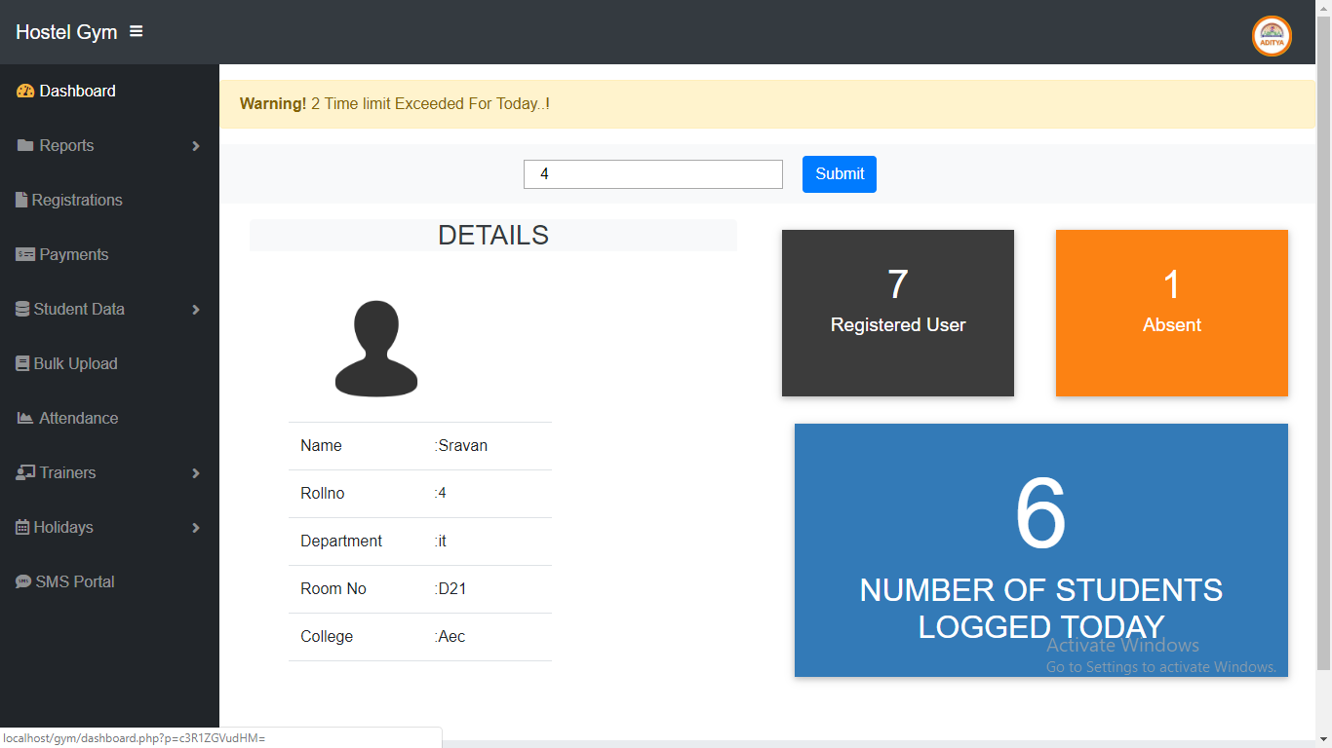

Text box: Enter/Scan Id

After scanning the id the the details will be loaded into the displayed page

**Registered Users** : Indicates the total number of Students Registered in the Gym.

**Number of Students logged in today** : Indicates the total number of students entered the Gym

**Absent** : Indicates the total number of students absent that day

**3. Reports**

Reports contains two list items as : This Month and Custom.

**3.1 This Month**

This Month item generates the monthly reports of the students.

**3.2 Custom**

Custom item generates the reports of custom dates which are manually given by the user.

**4. Registration**

Registration item includes the Registration Portal for Students .

**5. Payments**

Payment option is used for taking payment details.

**6. Student Data**

**6.1 View**

View Option views the data of registered students.

**6.2 Dues**

Dues option views the list of students who doesn't pay the fee.

**7. Bulk Upload**

Bulk Upload option is used to insert a large data into the database at one click.

**8.Attendance**

Attendance option is used to view the monthly attendance of the students.

**9. Trainers**

**9.1 Registration**

Registration option is used for Trainers registration.

**9.2 View Details**

View Details option is used to view the details of Trainers.

**9.3 Attendance**

Attendance option is used to generate the monthly attendance of Trainers.

**9.4 Trainers Log**

Trainers Log option is used to view the entire attendance of the Trainers till the present date include daily login time and logout time.

**10. Holidays**

**10.1 View**

View option is used to view the list of holidays.

**10.2 Add**

Add option is used to Add Holidays.

**11. SMS Portal**

SMS Portal option is used to send announcements to the registered students .

**Conclusion**

The Hostel Gym which is computerized will be much faster and reliable than the previous existing system. The paper work is reduced at the time of registering students.